Bees in Laax
G
Apiaries and beehives in the laax central and agglomeration. Collected by QField for QGIS.
OPENGIS.ch

Apiary
European honey bee Buckfast bee Carniolan honey bee
Fields
Colza Grass Lavender

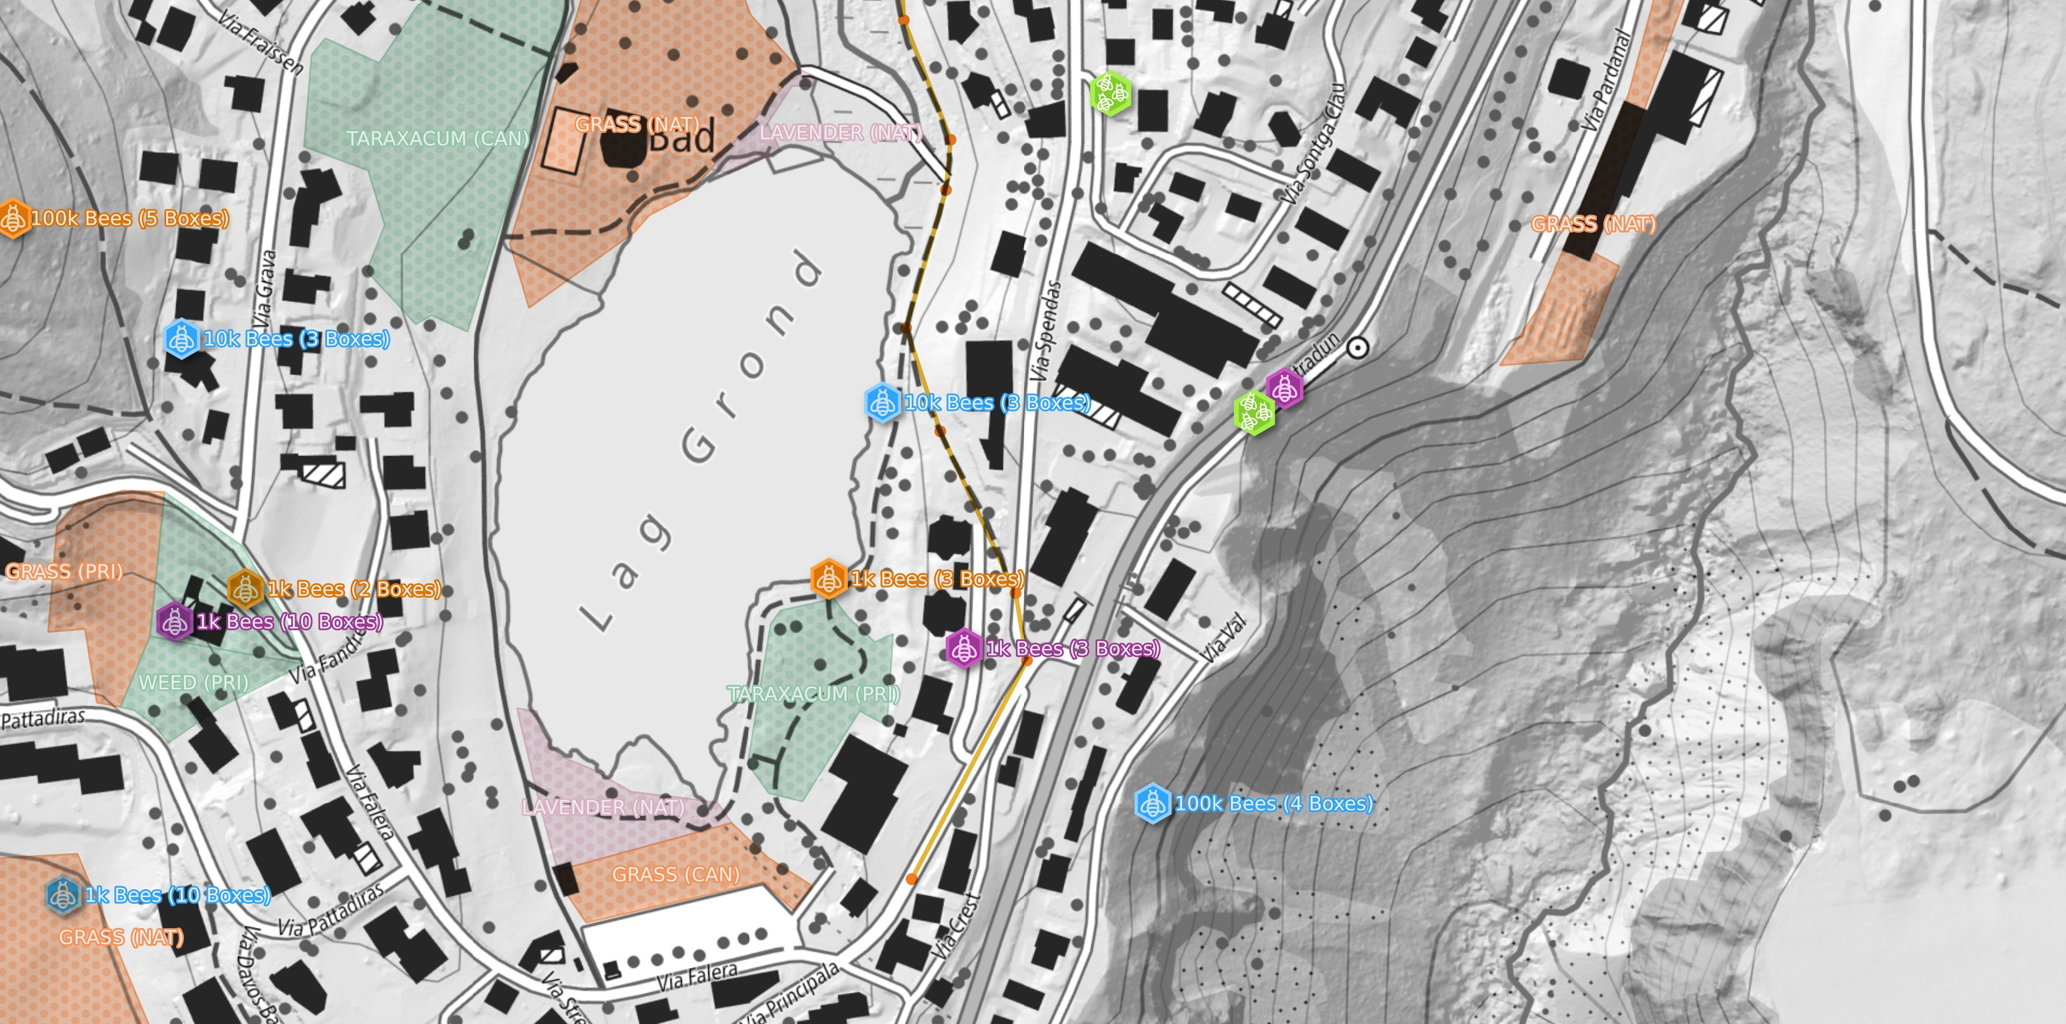









0 70 m
Dandelions Weed

